**Sprint 4 Plan**

*Okinawa Memory Initiative*

*The Okinawaners*

**Sprint Completion Date**: 12/2/18

**Revision:** 1.1

**Revision Date:** 12/2/18

*Note: Kevin 11:59pm Saturday 11/24/18 finish image hosting/ backend*

*11/25 Sunday at Kevin's House 7:00pm for merging party + polish*

**Goal:**

We want to have a connected backend and be able to view the home page, events, donate page, and documents page. The website should be fully functional by the end of this sprint.

**User Story 1:**

As a user, I want to be able to view the Events page, so that I can able to see the latest updates and posts regarding the Okinawa Memories Initiative on various social media platforms.

Task 1.1: Create jumbotron for the events page (< 1 hour)

Task 1.2: Create separate section for the Facebook posts posted by the Okinawa Memories Initiative team recently. (1 hour)

Task 1.3: Create subsection that displays the latest tweet from the Okinawa Memories Initiative Twitter account (1 hour).

Task 1.4: Create an online calendar that is supported by the Google APi that would display important dates pertaining to this university undergraduate research team. (2 hours)

**User Story 2:**

As a user, I want to be able to access the Donate page by clicking on the Donate Tab, so that I can make donation to UCSC’s Okinawa Initiative research group.

Task 2.1: Link the Donate Tab with the sister Donate website (<1 hour)

**User Story 3:**

As a user, I want to be able to access the Gail Project page by clicking on the Gail Project Tab, so that I can access the existing companion Gail Project page.

Task 3.1: Link the Gail Project Tab with the sister Gail Project website (<1 hour)

**User Story 4:**

As a user, I want to be able to filter documents in the Documents page, so that I can view documents sorted by the alphabet, date created, or oldest documents first.

Task 4.1: Make filter feature work appropriately when clicked (3 hour)

**User Story 5:**

As a user, I want to be able to access the appropriate YouTube Videos within the Vault page so that I may view the desired videos about Okinawan history.

Task 5.1: Have the Youtube videos dynamic and have the appropriate ones show up (1 hour)

**User Story 6:**

As a user, I want to be able to access the Okinawa website, so that I can enjoy learn about Okinawa history and enjoy the website’s features.

Task 6.1: Deploy Django application to AWS Elastic Beanstalk ( 5 hours )

Task 6.2: Put documents into Django’s persistence database ( 8 hours )

Task 6.3: Write a get/query function in the backend to get pictures from Django Databases ( 8 hours )

Task 6.4: Write a get API for FE developers to get pictures (4 hours)

Task 6.5: Host the website on Elastic Beanstalk (2 hours)

Task 6.6: Configure Django application for Elastic Beanstalk and frontend (3 hours)

Task 6.7: Frontend merging (6 hours)

**Team Roles:**

Kevin Tran: Project Owner, {UI design, Frontend}

Jeff Liao: Backend, {Frontend}

Tina Peng: Frontend {UI design, Backend}

Wellford Chan: Front End { Back End Integration }

Ankita Upadhyay: Backend {Frontend}

Alfred George Francisco Milan III: Frontend {Full Stack, Backend}

**Task Assignments:**

Kevin Tran: (User Story 6: Task 6.1, 6.2, 6.3, 6.4, 6.5, 6.6)

Jeff Liao: (User Story 6: Task 6.1, 6.2, 6.3, 6.4, 6.5, 6.6)

Tina Peng: (User Story 2: Task 2.1; User Story 3: Task 3.1)

Wellford Chan: (User Story 6: Task 6.1, 6.2, 6.3, 6.4, 6.5, 6.6)

Ankita Upadhyay: (User Story 5: Task 5.1; User Story 4: Task 4.1)

Alfred George Francisco Milan III: (User Story 1: Task 1.1, 1.2, 1.3, 1.4)

**Initial Scrum Board:**

|  |  |  |  |
| --- | --- | --- | --- |
| Stories | ToDo | In Progress | Done |
| As a user, I want to be able to use the website and to be able to see the following pages: Home, About, Vault, Documents, Events, Donate, Gail Project, Login. | **Task 1.3:** Create subsection that displays the latest tweet from the Okinawa Memories Initiative Twitter account (1 hour).  **Task 1.4:** Create an online calendar that is supported by the Google APi that would display important dates pertaining to this university undergraduate research team. (2 hours)  **Task 2.1:** Link the Donate Tab with the sister Donate website ( 1 hour )  **Task 3.1:** Link the Gail Project Tab with the sister Gail Project website ( 1 hour ) | **Task 1.2:** Create separate section for the Facebook posts posted by the Okinawa Memories Initiative team recently. (1 hour)  **Task 4.1:** Make filter feature work appropriately when clicked (1 hour)  **Task 5.1:** Have the Youtube videos dynamic and have the appropriate ones show up (3 hour) | **Task 1.1:** Create jumbotron for the events page (< 1 hour)  **Task 6.7:** Frontend merging (6 hours) |
| As a user, I want to be able to see the documents from the database | **Task 6.5:** Host the website on Elastic Beanstalk (2 hours)  **Task 6.6:** Configure Django application for Elastic Beanstalk and frontend (3 hours) | **Task 6.3:** Write a get/query function in the backend to get pictures from Django Databases ( 8 hours ) | **Task 6.1:** Deploy Django application to AWS Elastic Beanstalk ( 5 hours )  **Task 6.2:** Put documents into Django’s persistence database ( 8 hours )  **Task 6.4:** Write a get API for FE developers to get pictures (4 hours) |

**Initial Burn Up Chart:**

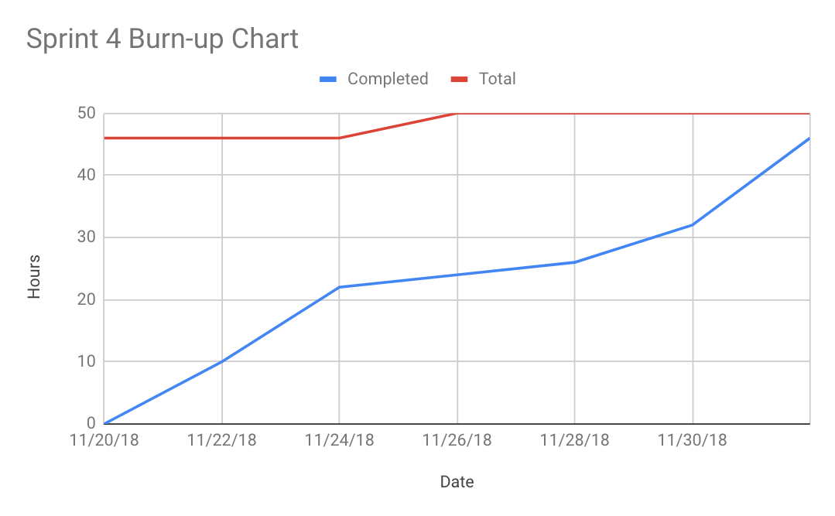

**Scrum Times:**

Tuesday 3:30pm

Thursday 2:00pm

Sunday 7:00pm